SIMATS ENGINEERING (SAVEETHA SCHOOL OF ENGINEERING)
Department of Computer Science and Engineering
ASSESSMENT TOOL 2– Case Study (2 QUESTIONS)

Course Code: | ITA05 | Course Title: | COMPUTER VISION
CO Assessed: | CO3 – Precision (BL4) | Assessment: | Assessment Tool 1 – Case Study
Weightage: | 40% of CIA | Total Marks: | 20 (2 Questions × 10Marks)
CO1 Statement: | Analyze and extract image features using detection and matching techniques for effective image representation and comparison..(BL4)
Student Name: | S.Vyshnavi | Reg. No.: | 192472041
Section / Batch: | 2024-slot D | Date: | 10.8.2026
2
Code of Conduct
I S.Vyshnavi(192472041) (Name / Reg No) certify that this submission is my original work and that I have adhered to the guidelines specified for this assessment. I understand that any violation of academic integrity rules will result in disciplinary action.

Signature of the Student:S.Vyshnavi
Instructions
- This test contains 2 questions, each carrying 10 marks. Total: 20 Marks.
- No negative marking. Unanswered questions carry zero marks.
- No calculators or electronic devices permitted.
- Duration: 60 minutes.

Section / Topic | Focus | Q Nos | Marks
Feature Detection and Matching | Preprocessing, Edge Detection, Harris Corner Detection, Hough Transform, SIFT | 1 | 10
Feature Detection and Matching | PCA, Image Representation, Feature Matching, Image Processing Applications | 2 | 10
GRAND TOTAL: |  | 20 Marks

Annexure A –Case Study
- A remote sensing application is used to align satellite images of the same geographical region captured at different times for monitoring environmental changes. The system initially relies on edge detection to identify matching regions between the images; however, due to differences in illumination, image orientation, and background details, the matching process becomes unreliable and produces inaccurate alignment results. The development team decides to replace the edge-based approach with Harris Corner Detection to identify stable and distinctive feature points. Analyze the limitations of edge detection in this application and explain how Harris Corner Detection improves feature localization, matching accuracy, and robustness for image registration under varying imaging conditions.

- An autonomous surveillance system continuously captures high-resolution color images to detect vehicles and pedestrians in real time. Processing the original color images directly increases computational complexity and slows down feature extraction, making it difficult to achieve the required processing speed. To improve system performance, the engineers consider converting the images into grayscale or binary representations before applying feature detection algorithms. Analyze the impact of different image representations on computational efficiency, edge detection, and feature extraction performance, and justify the most appropriate image representation for achieving accurate and reliable object detection in real-time computer vision applications.

Rubrics for Calculation

Criteria | Weig htage | Level 4 –  Exemplary | Level 3 –  Proficient | Level 2 –  Developing | Level 1 –  Beginning | Marks
Understanding of Case | 25 | Thorough understanding; clearly identifies all key issues | Good understandin g with most issues identified | Basic understanding  ; some issues missed | Poor understanding; problem not identified correctly
Application of Concepts | 25 | Effectively applies relevant concepts to analyze the case deeply | Applies appropriate concepts with minor gaps | Limited application of concepts | Fails to apply relevant concepts
Analysis | 20 | In-depth analysis with strong reasoning and insights | Good analysis with logical reasoning | Basic analysis with limited depth | Weak or no analysis; lacks reasoning
Solution Design | 20 | Innovative, feasible solutions with strong justification | Logical solutions with adequate justification | Basic solutions with weak justification | Incorrect or no solution provided
Clarity | 10 | Clear, well-structured, and easy to understand | Organized and understanda ble presentation | Limited clarity and structure | Poor clarity; difficult to understand

Faculty In-charge
Signature:
Date:

Harris Corner Detection for Satellite Image Registration Introduction
In remote sensing, satellite images of the same geographical region are often captured at different times to monitor changes such as deforestation, urban growth, floods, crop development, and land-use changes. Before comparing these images, they must be accurately aligned. This process is called image registration.
Initially, the system uses edge detection to identify corresponding regions. However, edges are often unreliable because they can change due to illumination, orientation, noise, and background variations. Harris Corner Detection provides more stable feature points that can be used for accurate registration.

Limitations of Edge Detection
Edge detection identifies locations where there is a sudden change in image intensity. For example:
  - Buildings produce strong edges.
  - Roads produce long edges.
  - Forest boundaries produce edges.
  - Mountains and geographical boundaries may also produce edges. However, using edges alone for satellite image registration has several problems.

Sensitivity to illumination
Images captured at different times may have different sunlight conditions. Shadows and brightness changes can modify the appearance of edges.

Edges are not highly distinctive
An edge only represents a boundary. Many different locations can have similar edge structures.
For example, several buildings may have parallel edges. It becomes difficult to determine which edge in one image corresponds to an edge in another image.

Poor localization
An edge usually contains many pixels along a continuous line. Therefore, selecting one exact point from an edge for matching is difficult.

Background variations
Trees, clouds, shadows, water, and other background objects can produce additional edges, causing false matches.

Orientation changes
If the satellite images are rotated or geometrically transformed, the appearance and position of edges may change significantly.

Harris Corner Detection
Harris Corner Detection identifies corners, which are points where the image intensity changes significantly in two different directions.
For example, the corner of a building contains strong intensity changes both horizontally and vertically.
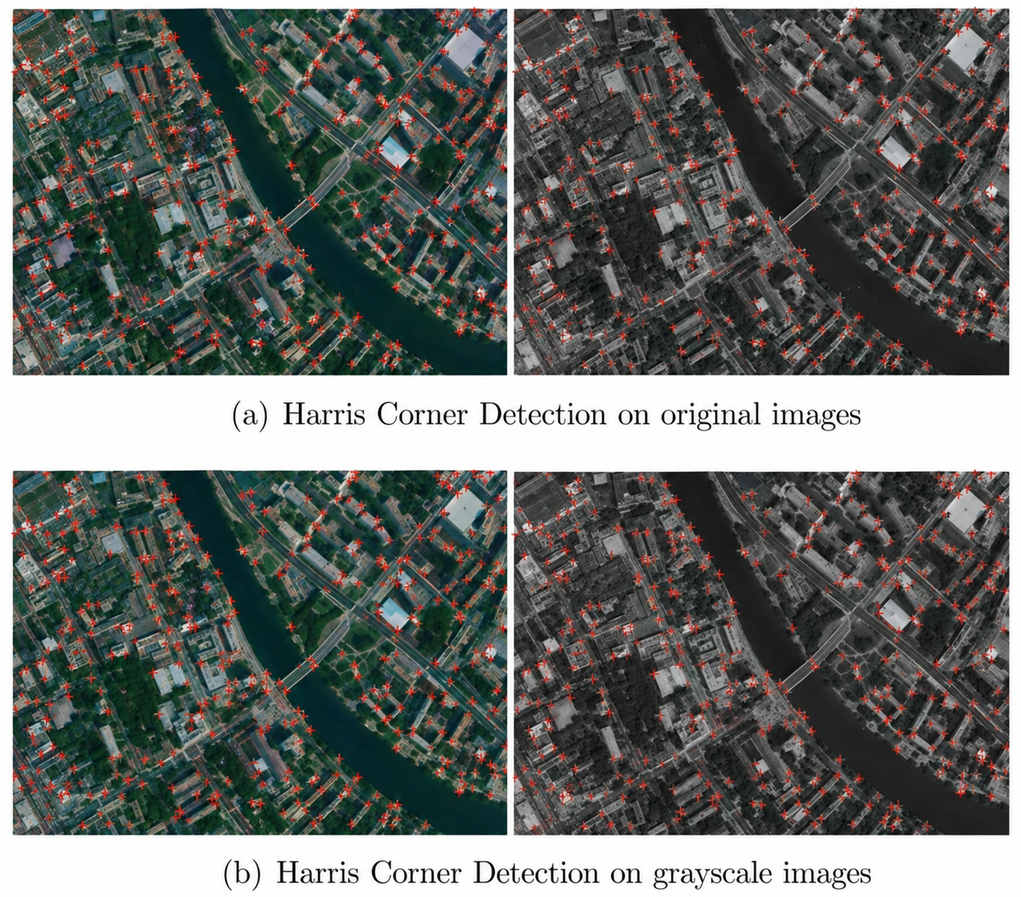

{l

Corne Detection· Basic idea

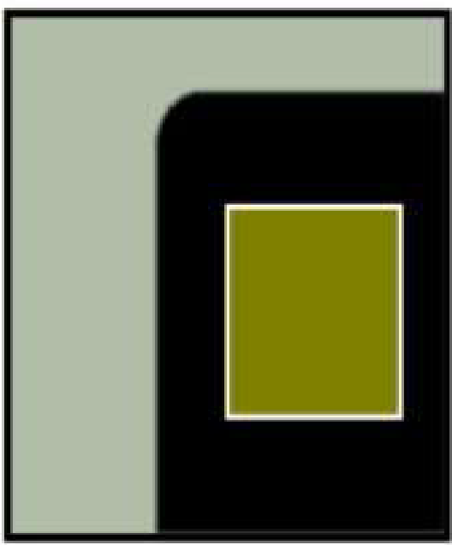
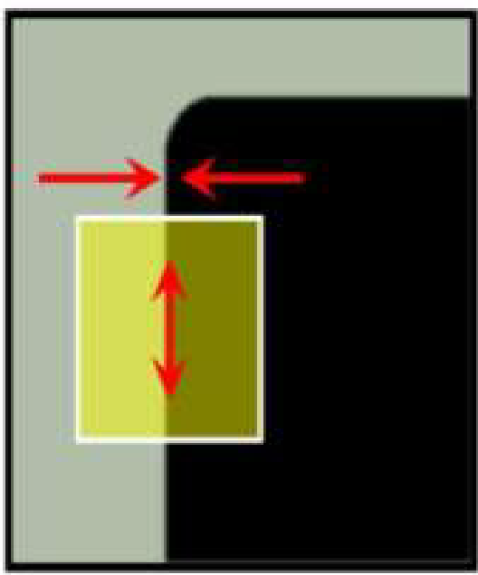
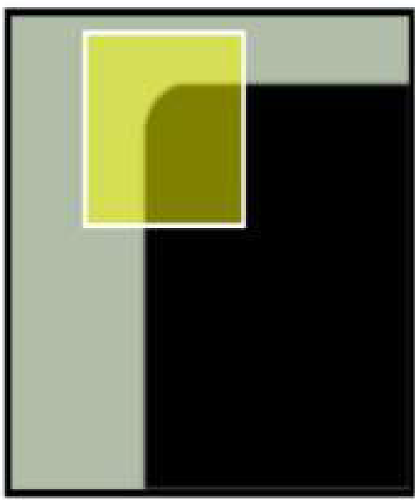


"flat' region: no change in all directions
'edg ' : no change along the edge
direction
'cor er" : significant change in all directions
with small shift

The basic idea is:
Image → Grayscale → Calculate gradients → Structure matrix → Harris response

→ Select strong corners
The Harris response is commonly calculated using:
where:
• = structure tensor / second-moment matrix
• = determinant of the matrix
• = trace of the matrix
• = Harris constant, generally around 0.04–0.06 A large positive value of indicates a strong corner.

How Harris Improves Image Registration

- Better Feature Localization
Corners provide specific points rather than long continuous edges.
For example, the corner of a building can be represented by one precise coordinate: These coordinates can be compared between two satellite images.
Therefore, Harris provides more precise feature localization.

Better Matching Accuracy
Corners are more distinctive than simple edges. Consider a building:

Edge-based:

Corner-based:

●
|
|
|
The corner contains information about intensity changes in multiple directions. Therefore, the system can more reliably determine that a corner in Image 1 corresponds to the same geographical location in Image 2.

Robustness to Illumination Changes
Satellite images taken at different times may have different brightness levels.
Harris uses local intensity gradients rather than simply comparing the absolute brightness of pixels.
Therefore, important structural features such as:
  - building corners
  - road intersections
  - field boundaries
  - structural junctions
can remain useful even when illumination changes.

Robustness to Background Details
Background objects can generate many unwanted edges. Harris focuses on points where intensity changes occur in multiple directions.
This reduces the number of ambiguous features and improves matching.

Useful for Geometric Transformation
Satellite images may have:
  - translation
  - rotation
  - scaling
  - slight perspective differences
Corner points provide strong reference locations for estimating the geometric transformation between images.
For example:
where represents the transformation required to align the images.

Improved Registration
After detecting Harris corners in both images, corresponding points can be matched. The transformation can then be estimated using methods such as:
  - Affine transformation
  - Homography
  - RANSAC
Finally, one image is warped so that both images overlap correctly.

Comparison
Feature Edge Detection Harris Corner Detection Detects Boundaries/edges Distinctive corner points Localization Less precise More precise
Matching Difficult for repetitive edges Easier using distinctive points Illumination robustness Relatively low Better
Background sensitivity High Lower
Feature uniqueness Low to moderate High
Registration suitability Limited Very suitable

Conclusion
Edge detection is useful for identifying boundaries, but it is not ideal as the primary feature for satellite image registration because edges are often long, repetitive, illumination-sensitive, and difficult to localize precisely.
Harris Corner Detection identifies stable and distinctive points where intensity changes in two directions. These points provide better localization, more reliable matching, and improved robustness against illumination and background variations.
Therefore, replacing edge detection with Harris Corner Detection significantly improves the accuracy and reliability of satellite image registration, making it more suitable for environmental monitoring applications.

Choosing Grayscale or Binary Images for Real-Time Object Detection Introduction
An autonomous surveillance system continuously captures high-resolution color images to detect vehicles and pedestrians. Processing full RGB images requires more computational resources because every pixel contains three color channels.
To increase processing speed, the images can be converted into:

Grayscale representation
- Binary representation
The choice of representation affects computational efficiency, edge detection, feature extraction, and object detection accuracy.

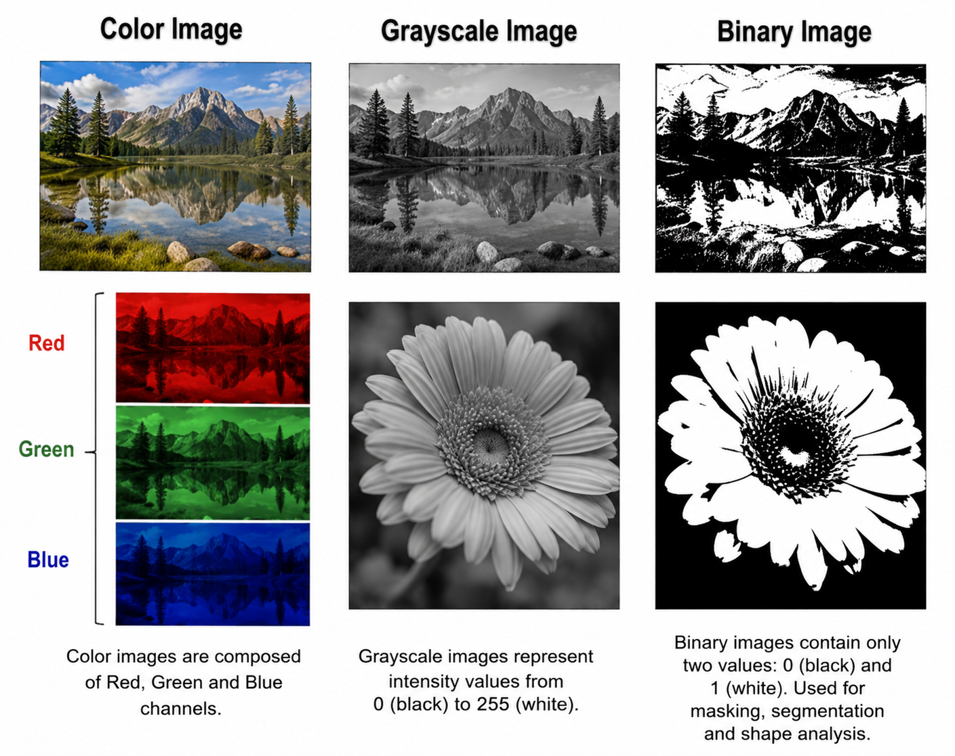

@ flgurt 1 - □ •
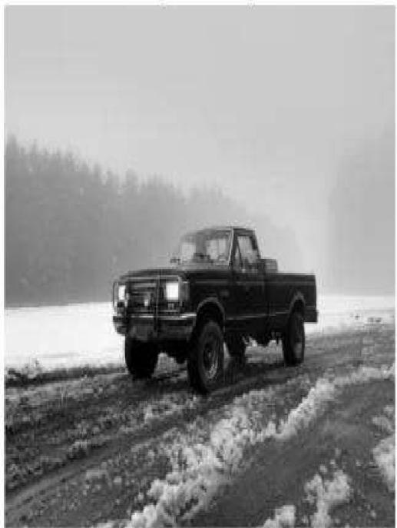
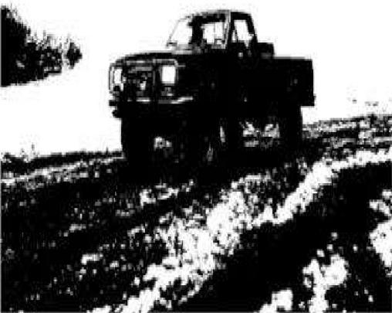
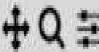
Original Image THRESH_BINARYImage

Color Image Representation
A color image normally contains three channels:
For an image of size :
pixel values must be processed. This increases:
  - memory usage
  - processing time
  - feature extraction complexity
However, color information can be useful for distinguishing objects.
For example, a red vehicle and a green background may be easily separated using color information.

Grayscale Representation
A grayscale image contains only one intensity channel. Instead of:
each pixel has a single value:
Usually the intensity ranges from:
where:
  - 0 = black
  - 255 = white
A common conversion is:

Advantages
Reduced computational complexity
Only one channel needs to be processed instead of three.

Faster feature extraction
Algorithms such as:
  - Harris Corner Detection
  - SIFT
  - Canny
  - Sobel
  - HOG
can work effectively with grayscale images.

Good edge detection
Edges are primarily detected using intensity changes.
For example, the Canny edge detector normally works on a grayscale image.

Reduced memory requirement
A grayscale image requires approximately one-third of the channel data of an RGB image.

Binary Representation
A binary image contains only two values:
or commonly:
For example:
Original image
↓
Grayscale
↓
Thresholding
↓
Binary image
Thresholding can be represented as:
where is the threshold.

Advantages
Binary images are extremely simple to process. They can be useful for:
- object segmentation
- shape analysis
- contour detection
- connected component analysis
They require very little computational processing.

Problems with Binary Representation
Although binary images are computationally efficient, they lose a large amount of information.

Loss of intensity information
A grayscale image contains 256 possible intensity levels, whereas a binary image contains only two.
Therefore:
much information is lost.

Poor performance under changing illumination
Suppose a pedestrian is captured under:
  - sunlight
  - shadow
  - nighttime lighting
A fixed threshold may incorrectly classify parts of the person as background.

Loss of object details
Small details such as:
  - clothing patterns
  - vehicle structure
  - body contours
  - facial/shape details
may disappear after thresholding.

Incorrect segmentation
If the vehicle and background have similar intensity values, thresholding may fail to separate them.
Therefore, binary representation is not always reliable for real-world surveillance.

Comparison of Image Representations
Property RGB Grayscale Binary
Channels 3 1 1
Computational cost High Low Very low
Memory usage High Lower Very low
Intensity information High Moderate Very low
Edge detection Good Excellent Depends on threshold Feature extraction High cost Efficient Limited
Object details Excellent Good Poor Illumination robustness Better in some cases Moderate Low Real-time processing Expensive Very suitable Very fast General object detection Excellent Very good Limited

Most Appropriate Representation
For a real-time surveillance system, grayscale representation is the best general choice.
The processing pipeline can be:

Color Image
↓
Grayscale Conversion
↓
Noise Reduction
↓
Edge / Feature Detection
↓
Object Detection
↓
Vehicle / Pedestrian Recognition
Grayscale provides a good balance between speed and accuracy.
It significantly reduces computational complexity while preserving the intensity information required for edge and feature detection.
Binary images are faster but should generally be used after segmentation or thresholding, rather than as the primary representation for general vehicle and pedestrian detection.

Example
Suppose a surveillance camera captures:
RGB Image 1920 × 1080 × 3
After grayscale conversion:
Grayscale
1920 × 1080 × 1
The feature detector now processes only one intensity channel.
This reduces the amount of data while retaining important structures such as:
- object boundaries
- corners
- shapes
- contours
- textures
Therefore, algorithms such as Harris, SIFT, HOG, Sobel, and Canny can operate efficiently.

Conclusion
RGB images preserve the maximum amount of information but require greater computational resources. Binary images provide the highest processing speed but lose significant image information and are sensitive to threshold selection.
Grayscale is the most appropriate representation for real-time vehicle and pedestrian detection because it provides an effective compromise between computational efficiency and detection accuracy. It reduces processing requirements while retaining sufficient intensity information for reliable edge detection and feature extraction.

